**Professionalism and Employability**

**Testing and Vulnerabilities**

**Adam May – 17129303**

**Adam Lewis - 17021294**

**Jake Bulmer - 17144132**

**Liam Newton -**

**Vulnerabilities**

**Authentication Vulnerabilities**

Authentication vulnerabilities can be used by hackers to find loops within the user login stage. Having a secure login page is common practice and vital to the security of a company’s data. Studies show that an alarming amount of people use the password “password” as their password, along with other overly simple phrases such as their birthday or a name. It is estimated that between 15% and 50% of passwords fall into this category[1] and because of this, hackers can easily guess passwords and gain sensitive information.

If users within the company refrain from using simple passwords or the company provide passwords for the users, then the risk of authentication vulnerabilities arising should be reduced. It is also vital that each stage of the authentication process works correctly, if a person can enter a wrong password and still gain access to the home page then the authentication process has failed, and vulnerabilities arise.

**SQL Injection**

An SQL injection is where computer hackers interfere with database queries that an application makes. When they do this correctly, it allows the hacker to see sensitive information that they otherwise would not have been able to access. This could leave systems extremely vulnerable if a login database containing employee’s usernames and passwords were compromised, giving the hackers the ability to essentially bypass that level of security relatively easily.

A common way to combat this type of vulnerability is through defensive coding practices. It is found that the root cause of SQL injection vulnerabilities is insufficient input validation.[2] An example of a defensive coding practice is input type checking. Input type checking is the practice of checking that a string or an integer has the correct type[3] in doing so you increase the security of the information stored within it. With a better understanding of defensive coding practices and more attention to detail we can reduce the risk of SQL injection attack.

**Insecure Cryptographic Storage**

When information, files or data are not stored securely, they become vulnerable. Cryptographic storage is a method of securely storing something behind a wall of encryption. There are many different encryption algorithms available for people to use to secure their data, but sometimes people may use the wrong algorithms in the wrong context or for the wrong data type. Insecure Cryptographic Storage occurs when this happens, and a hacker targets the implementation or the algorithm itself.[4]

Fortunately, there are some easy countermeasures that you can take to ensure that your encryption works well. An example of one of these is that you should only use approved public algorithms such as AES, RSA and public key. Another example of a way to decrease the vulnerability of the encryption would be to use salting hashing techniques with your own logical operations implemented. Salt is random data that is used an addition input to a verification system. Applying this technique to passwords will make them more secure[5] and keep your data safe from hackers.

**Format String Vulnerability**

String formats are used to specify what datatype is stored within the string. Although many other datatypes exist, and the vulnerability applies to all of them. Float is a datatype used to store numbers with decimal points and integers or “int” are commonly used to store whole numbers[6]. When you use an int to store a float, issues can arise.

Format String Vulnerabilities occur when incorrect string formats are used to store data. Hackers can then overload these formats, crashing systems and cause memory leaks which will in turn expose all the data found within the compromised string.[7] To prevent or greatly reduce the threat from hackers you must ensure that you use the correct type of format for the string that you are using.

**Testing – GUI**

**Login Functionality**

|  |  |  |  |  |
| --- | --- | --- | --- | --- |
| Test No. | What is being entered | Expected Result | Outcome | Proof |
| 1 | Valid Username and password | Allows me to continue to the next page | Allowed me to carry on to the policies | Appendix 1 |
| 2 | Valid username but invalid password | Gives me an error telling me credentials are invalid | Gave me an error | Appendix 2 |
| 3 | Invalid username but valid password | Gives me an error telling me credentials are invalid | Gave me an error | Appendix 3 |
| 4 | Invalid username and invalid password | Gives me an error telling me credentials are invalid | Gave me an error | Appendix 4 |

**Appendices**

Appendix 1

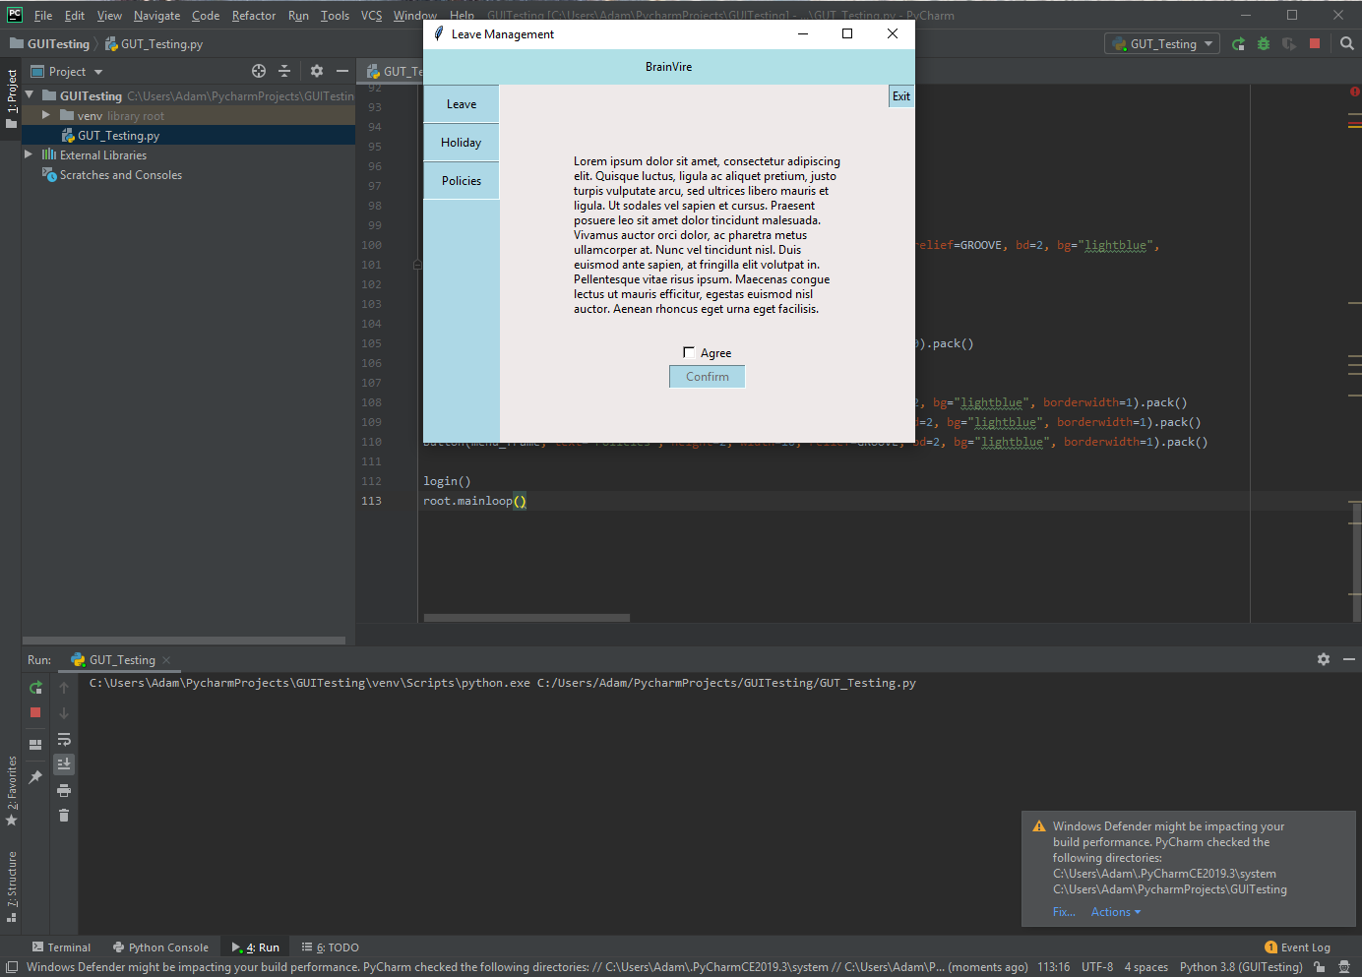

Appendix 2

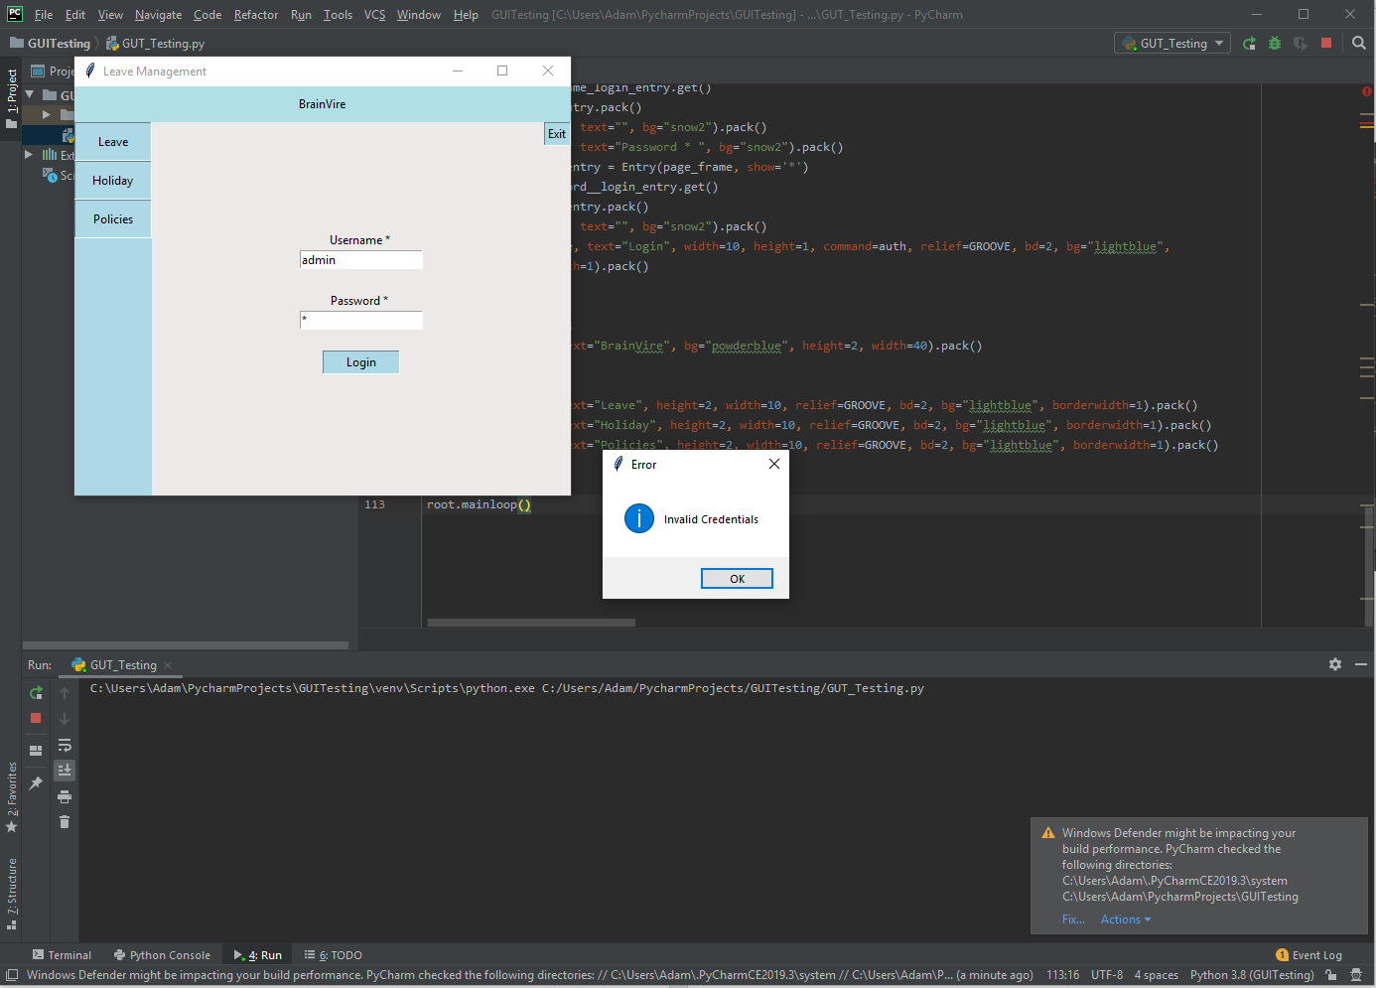

Appendix 3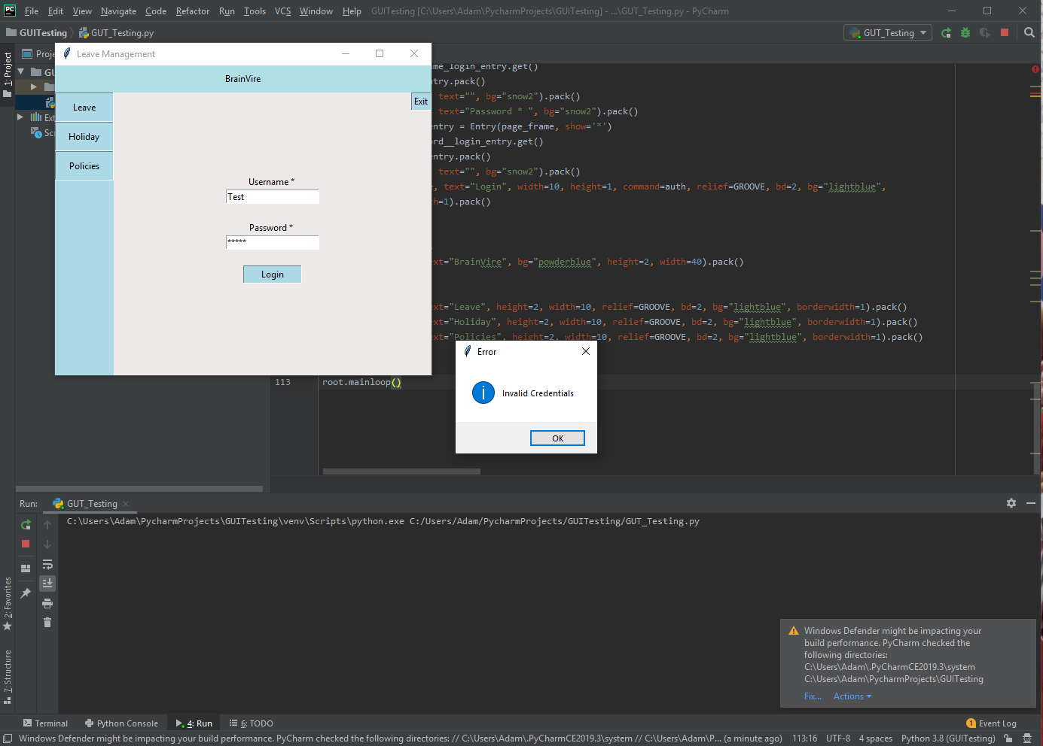

Appendix 4

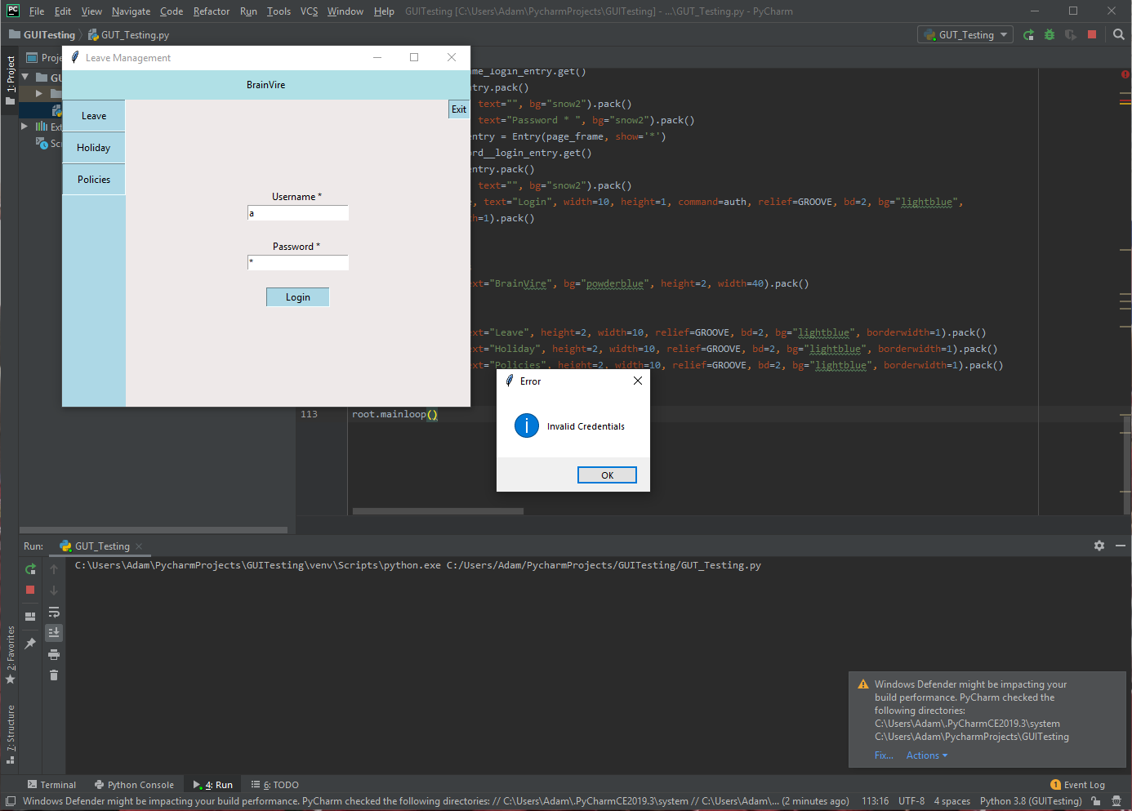

**References**

James E. Weber, Dennis Guster, Paul Safonov, and Mark B. Schmidt - Information Security Journal: A Global Perspective – 2008

William G.J. Halfond, Jeremy Viegas, and Alessandro Orso - A Classification of SQL Injection Attacks and Countermeasures – 2006

Chris Anley - Advanced SQL Injection In SQL Server Applications – 2002

Assist. Prof. Parvin V. Ami, Assist. Prof. S. C. Malav - Top Five Dangerous Security Risks over Web Application – 2013

S Kharod - An improved hashing based password security scheme using salting and differential masking – 2015

M Huenerfauth – An Introduction to Python – 2009

CS Wright - Exploiting Format Strings with Python - 2011

1. James E. Weber, Dennis Guster, Paul Safonov, and Mark B. Schmidt - Information Security Journal: A Global Perspective - 2008
2. William G.J. Halfond, Jeremy Viegas, and Alessandro Orso - A Classification of SQL Injection Attacks and Countermeasures - 2006
3. Chris Anley - Advanced SQL Injection In SQL Server Applications - 2002
4. Assist. Prof. Parvin V. Ami, Assist. Prof. S. C. Malav - Top Five Dangerous Security Risks over Web Application - 2013
5. S Kharod - An improved hashing based password security scheme using salting and differential masking - 2015
6. M Huenerfauth – An Introduction to Python – 2009
7. CS Wright - Exploiting Format Strings with Python - 2011